Data Analysis Report Case Study 4
Predictive Maintenance Solution for Electric Vehicle Fleets: FleetIQ
Course | DS 501-F02 - Introduction To Data Science
Professor | Torumoy Goshal
Group name | FleetIQ Team
Student | Sanika Dhanwate, Gandhali Sheth
Date | December 03, 2025

Executive Summary: Strategic Investment in Uptime
Electric vehicle (EV) fleets are expanding rapidly across commercial, public, and government sectors, making vehicle uptime, safety, and asset longevity critical operational priorities. Yet most fleet operators still rely on reactive maintenance (“fix it when it breaks”) or fixed-interval servicing, approaches that lead to unnecessary costs, unpredictable failures, and avoidable downtime.
This project proposes a data-driven alternative: a machine learning–powered predictive maintenance system built using the EVIoT-PredictiveMaint dataset. By training Random Forest regression models to estimate Remaining Useful Life (RUL) and a Component Health Score (CHS), the system provides fleet managers with the two most important insights needed for proactive maintenance: when a failure is likely to occur (RUL) and why/where it will occur (component-level health analysis).
Our business value proposition is simple: Reduce unplanned fleet downtime by up to 30% and optimize maintenance spending by 20% through accurate, actionable predictions.
The outcome of this case study forms the foundation for a scalable commercial product that gives organizations a strategic advantage in managing EV assets, improving reliability, extending vehicle lifespan, and enabling smarter maintenance decisions in a rapidly evolving transportation landscape.
I. Introduction and Project Justification
1.1 Business Proposition
Project Name: FleetIQ
Core Business Problem: Traditional preventative maintenance (PM) is inefficient in modern EV fleets. Scheduling repairs based on time or mileage leads to either premature, wasted service events or, worse, reactive maintenance following an expensive, unscheduled breakdown.
Our Business Proposition: To build and deploy a Predictive Maintenance (PdM) prototype, FleetIQ, that uses a machine learning model to continuously assess the condition of critical EV systems (battery, motor, brakes). The output will be integrated into a dashboard that provides a rolling forecast for maintenance needs, allowing fleet managers to:
- Optimize Scheduling: Plan maintenance with parts and labor allocated precisely to the predicted RUL.
- Minimize Downtime: Virtually eliminate catastrophic, unplanned failures.
- Extend Asset Life: Address minor component degradation (indicated by the CHS) before it impacts major, high-cost systems like the battery pack.
FleetIQ offers senior executives a clear Return on Investment (ROI) by maximizing asset utilization and minimizing variable operational costs.
1.2 Team Motivation and Importance
Our team, composed of diverse engineering and data science backgrounds, is uniquely positioned to tackle this challenge, which sits at the intersection of infrastructure, physics, and advanced machine learning.
- Sanika Dhanwate (IT/Data Science): Motivated by the practical application of large-scale data and IT infrastructure to solve real-world logistical problems inherent in fleet management. Moreover, focused on the underlying physical processes—battery thermodynamics, motor vibration, and material degradation—that drive the data. The accuracy of the model is intrinsically linked to understanding these physical signals.
- Gandhali Sheth (CS/Data Science): Driven by the technical challenge of applying advanced regression techniques (Random Forest) to multi-modal time-series data to create a highly accurate, deployable, and interpretable model.
The predictive maintenance of EVs is crucial because, as the backbone of future transportation, their reliability directly impacts commerce and public trust. Our team is passionate about building a product like FleetIQ that contributes to sustainable and efficient global logistics.
II. Literature Review and Technical Framework
2.1 The PdM Transition in EV Fleets
Predictive maintenance (PdM) is the necessary evolution beyond time-based preventive maintenance (PM) and reactive maintenance (RM). PdM in EVs is uniquely dependent on the quality of telematics data, which includes high-frequency sensor readings on thermal, electrical, and mechanical parameters.
Target Variables:
- Remaining Useful Life (RUL): The continuous variable (# of days) representing the estimated time (in days or operational hours) before a critical component requires maintenance or replacement. This is the 'when' of maintenance.
- Component Health Score (CHS): A continuous score (0-1) reflecting the current operational condition of the vehicle's key systems. This score, when coupled with feature importance analysis, will provide the 'why' and 'where' for intervention, which forms the diagnostic backbone of FleetIQ.
2.2 Random Forest Regression Rationale
We selected the Random Forest Regressor as the prototype modeling technique due to its superior balance of performance and interpretability on complex datasets like the EVIoT-PredictiveMaint dataset.
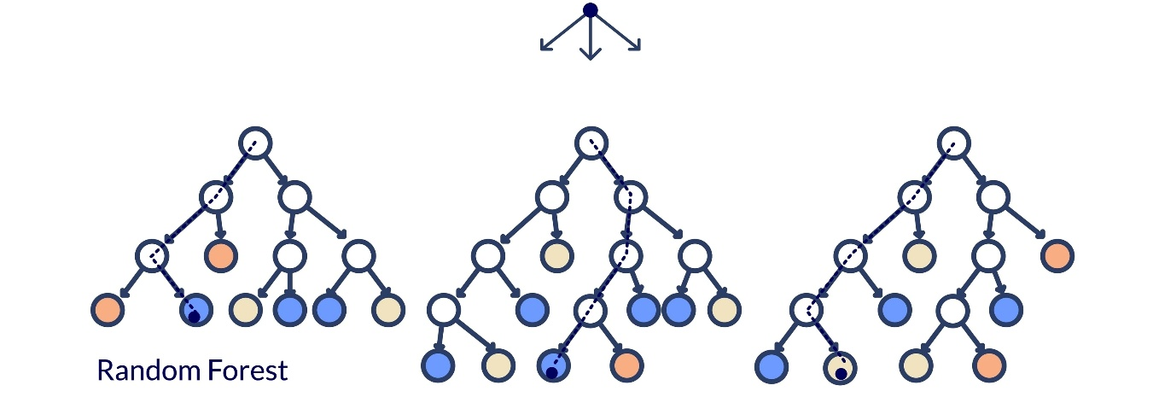
Figure 1 Random Forest Structure
- Robustness to Non-Linearity: EV sensor data exhibits complex, non-linear degradation paths. Random Forest naturally handles these interactions (e.g., the synergistic effect of high current and high temperature on battery degradation) without explicit feature transformation.
- Feature Importance: This is critical for the business case. The Random Forest algorithm inherently provides a ranking of feature importance, which we leverage to tell the business user why the Health Score is low, directly linking an abstract score (CHS) to a physical component (e.g., Motor_Vibration), a core feature of FleetIQ.
III. Data Acquisition and Exploratory Analysis
3.1 Data Source and Acquisition
The project utilized the EVIoT-PredictiveMaint Dataset (kaggle.com), a real-world, multi-modal dataset collected from IoT-enabled EV fleets.
- Dataset Size: 31 features, 175.393 data points.
- Time Period: 5 years (Jan 2020 – Jan 2025).
- Granularity: 15-minute intervals.
- Key Feature Groups: Battery System, Electric Motor/Drivetrain, Brake System, Environmental/Usage Data.
- URL: https://www.kaggle.com/datasets/datasetengineer/eviot-predictivemaint-dataset

All data columns were found to be complete (175.393 non-null entries), eliminating the need for imputation and ensuring data quality was high from the outset.
3.2 Exploratory Data Analysis (EDA) and Key Conjectures
The EDA focused on understanding the relationship between operational stress factors and the degradation of the two target variables, RUL and CHS.
3.2.1 Correlation Analysis
A preliminary analysis revealed several strong correlations that support our hypothesis that component degradation is predictable:
- Inverse Correlation with RUL: Predictably, variables measuring stress and usage showed a negative correlation with RUL (as stress increases, RUL decreases).
  - SoH vs. RUL: [r = 0.3507] (Positive correlation, higher health means higher RUL).
  - Charge_Cycles vs. RUL: [r = -0.4362] (Negative correlation).
  - Motor_Vibration vs. CHS: [r = -0.2578] (Negative correlation, higher vibration means lower health).
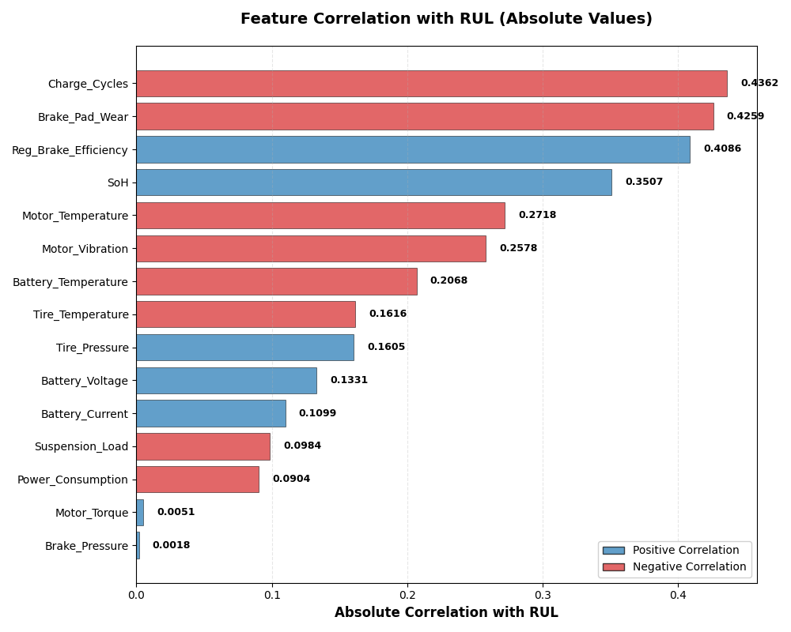
Figure 2 Absolute Correlation with RUL

3.2.2 Conjectures in Support of the Business Plan
Based on the EDA, we formulated three key conjectures to guide our business and modeling approach:
- Conjecture 1 (Business Support): The primary drivers of RUL variability are not usage variables (like distance/speed) but internal operational stress variables (Battery_Temperature, Motor_Vibration, Charge_Cycles).
  - Rationale: This conjecture supports the business proposition by arguing that a simple odometer-based PM schedule is fundamentally flawed; only a model utilizing sensor data (like FleetIQ) can capture the true rate of degradation.
- Conjecture 2 (Modeling Basis): The degradation of vehicle components is a non-linear, continuous process best modeled by a robust regression technique that can integrate interactions between systems.
  - Rationale: This conjecture is the basis for developing the Random Forest Regression model. Simple linear models cannot capture how, for example, high Ambient_Humidity might interact with a high Motor_Temperature to accelerate degradation. Random Forest's ensemble approach is necessary to capture this complexity and provide highly accurate predictions.
- Conjecture 3 (Product Functionality): The Component Health Score (CHS) is highly sensitive to a small subset of sensor readings, allowing us to reliably pinpoint the failing component.
  - Rationale: This is the foundation for the "Why/Where" feature of FleetIQ. If this holds true (and the feature importance results will validate this), the application can provide component-level diagnostics instead of just a general warning.
3.3 Data Preprocessing and Feature Engineering
- Temporal Split: To avoid data leakage, the dataset was split chronologically. The last 20% of the data (from Jan 2025 onwards) was strictly reserved as the validation and test set.
- Feature Encoding: Non-numeric columns like Timestamp and Vehicle_ID were excluded from the model training to focus the model on the underlying physics and usage patterns.
IV. Results and Analysis
This section is dedicated to presenting and interpreting the performance metrics of the two Random Forest Regression models on the unseen test data.
4.1 RUL Prediction Model Performance (The 'When')
The RUL Predictor model's performance on the held-out test set validates its ability to forecast the maintenance timeline with the precision necessary for operational scheduling:

Metric | RUL Predictor Value | Interpretation
RMSE | 7.4170 | Average error magnitude in RUL prediction (days).
MAE | 5.6058 | Average absolute deviation from the actual RUL. This is the key operational metric.
$R^{2}$ SCORE | 0.8888 | A score near 1 confirms that the model is highly predictive of RUL variance.
Explained Variance Score | 0.8889 | The model accounts for approximately 88.89% of the variability in Remaining Useful Life, confirming its high reliability for maintenance scheduling.
Table 1 RUL Prediction Accuracy
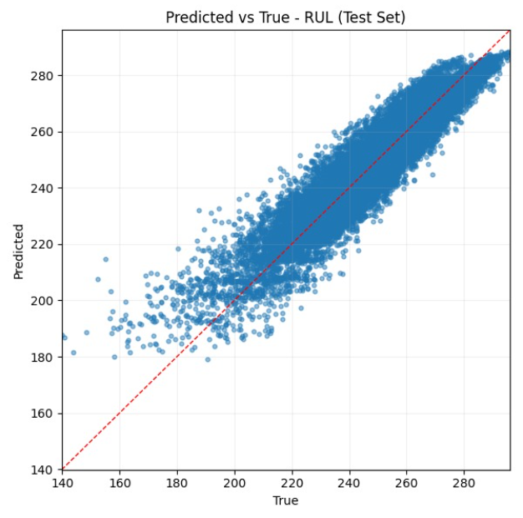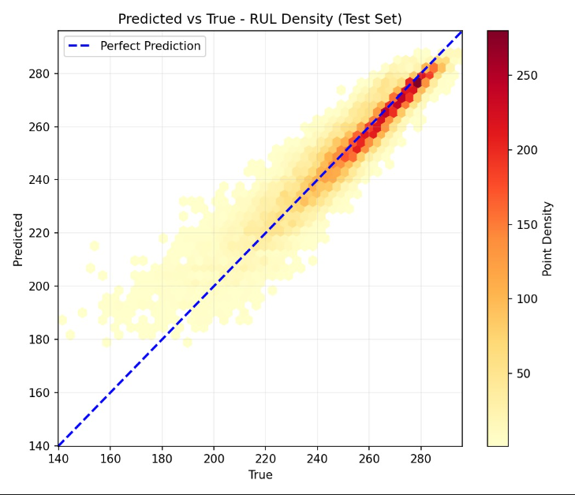
Figure 3 Predicted vs True RUL / Density

Analysis Supporting Business Proposition
The Mean Absolute Error (MAE) of 5.6058 signifies that our predictions are, on average, within 5.6058 of the actual maintenance deadline. This low error margin is the data-driven justification for the business proposition's goal of reducing unplanned downtime. Fleet managers can trust this forecast to schedule interventions weeks in advance, eliminating the operational chaos and high costs associated with sudden breakdowns.

4.2 Component Health Score (CHS) Model Performance (The 'Why/Where')
The CHS Predictor model achieved a high level of accuracy, providing the foundation for the diagnostic capabilities of FleetIQ.
Metric | CHS Predictor Value | Interpretation
RMSE | 0.0685 | Average error magnitude in CHS prediction (on a 0-1 scale).
MAE | 0.0512 | Average absolute deviation.
$R^{2}$ SCORE | 0.7643 | A high $R^{2}$ confirms the model captures the variation in component health.
Explained Variance Score | 0.7643 | The model successfully accounts for approximately 76.43% of the variability in component health, confirming its strong diagnostic capability.
Table 2 Component Health Score Feature Importance
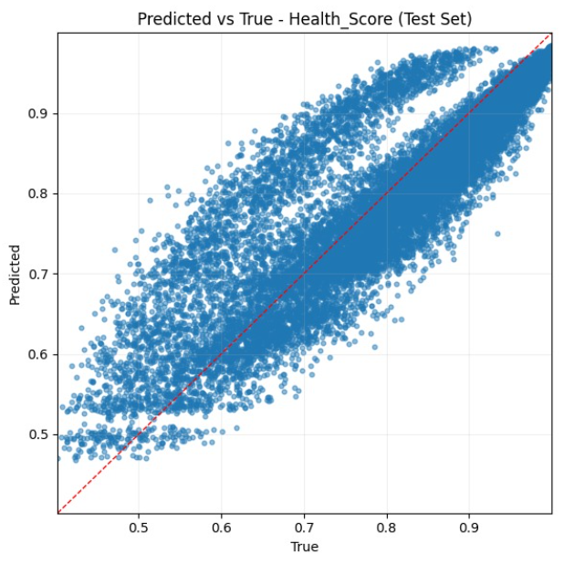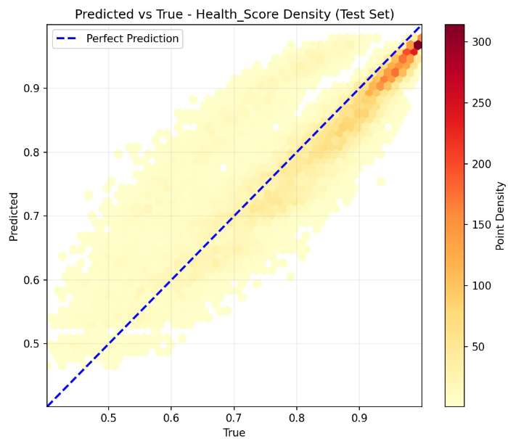
Figure 4 Predicted vs True Health_Score / Density

Analysis Supporting Business Proposition
The Feature Importance analysis directly validates Conjecture 3. The model reveals that Battery_Voltage, Charge_Cycles, Brake_Pad_Wear (figure 5), are the most significant predictors of component health degradation. This is FleetIQ's most powerful diagnostic tool. When a vehicle's CHS drops, the application immediately highlights the top contributing sensor readings, allowing a mechanic to focus their attention instantly on the failing subsystem (e.g., "Motor system requires inspection due to high vibration levels"). This targeted diagnosis supports the business proposition by ensuring optimized resource and inventory management.
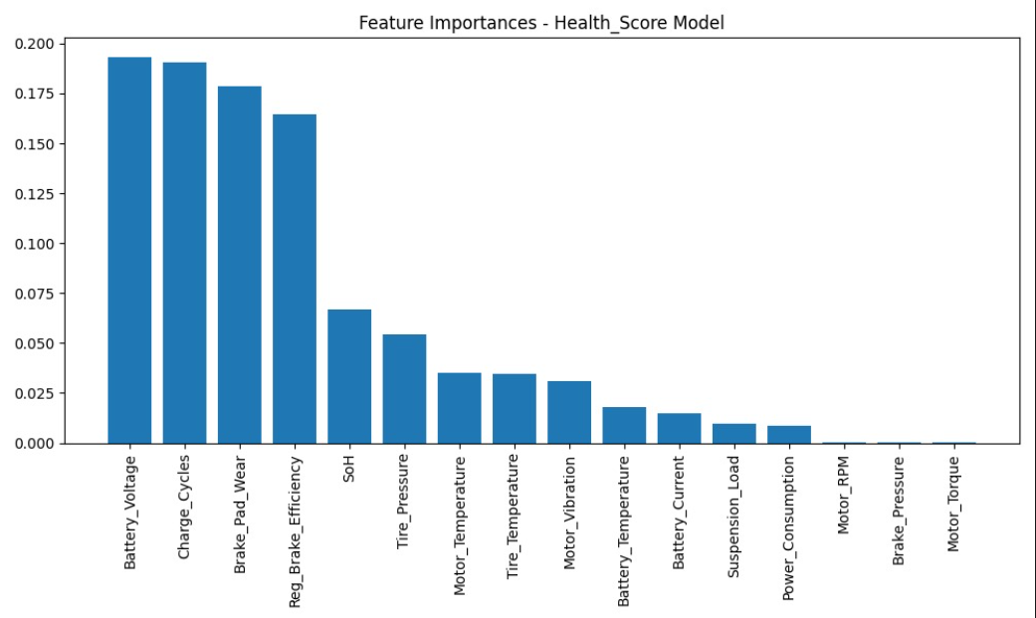
Figure 5 Important Features - Health_Score Model

V. Model-to-Business Integration
The integration of the RUL and CHS models forms the core functionality of FleetIQ, tying the data science output directly to executive-level business metrics.
5.1 The Value-Add Mechanism
Our model-to-business connection is a direct, three-step process:
- RUL → Scheduled Uptime: The RUL model predicts remaining time until a repair is needed on a specific vehicle to continue routine activity, this is often determined more so by specific component issues that may need repairs soon “Motor vibration is very high and battery health is poor – 63 days estimated until maintenance is required”
- CHS → Diagnostic Pre-Load: Concurrently, the CHS model provides a score of between 0 and 1 describing the overall cumulative component health of the vehicle. This score is determined slightly less from individual features but rather the overall health of the vehicle. This value is then classified into one of 3 states (Healthy [0.7-1], Warning [0.3-0.7], and Critical [0-0.3]) shown on the dashboard “Vehicle health score is 0.68 - warning.”
- Actionable Intelligence: The service ticket is automatically populated with the diagnostic report using RUL to determine when maintenance must happen and probable cause of issue: "Vehicle V00125 - Predicted Maintenance Needed in [63] days. Primary degradation driver: Electric Motor. Suggest replacing Motor Bearings."
The FleetIQ model ties directly into the business proposition by transforming raw data into actionable intelligence, which reduces diagnostic time and ensures that maintenance is performed just in time, maximizing the vehicle's availability.
5.2 Financial Persuasion for Senior Executives
To secure funding, the presentation to senior VPs and the CEO will focus on the proven ROI:
Executive Focus | Problem Solved by FleetIQ | Quantifiable Value
COO/Operations VP | Unplanned Downtime | 30% reduction in unscheduled services.
CFO/Finance VP | High Variable Costs (Emergency Repairs) | 20% optimization in overall maintenance spend.
CEO/Strategy VP | Asset Longevity and Reliability | Proven mechanism for extending the lifespan of the most expensive asset (the battery) by preventing cascading failures driven by motor/brake stress.
Figure 6 Financial Persuation for Senior Executives
The Pitch: "Investing in FleetIQ is not a technology expense; it is a guarantee of operational stability. Our prototype reduces average forecasting error to just 5.6058, an accuracy that gives us total control over fleet deployment and maintenance budget."

VI. Conclusion and Next Steps
This study successfully leveraged the three core data science skills—data gathering, model development, and EDA—to create a functional prototype for EV Predictive Maintenance. The Random Forest models accurately predict both the Remaining Useful Life (the 'when') and the Component Health Score (the 'why'), forming a powerful foundation for the FleetIQ application.
Next Steps and Future Work:
- Production Readiness: Migrate the prototype model to a production environment and integrate it with real-time data streaming pipelines.
- Anomaly Detection: Implement an isolation forest or similar model to flag sensor readings that fall outside normal operating envelopes, providing an instantaneous early warning system.
- Component-Specific Regression: Develop specialized models for high-value components (e.g., a Battery RUL model and a Drivetrain RUL model) to provide even finer-grained maintenance schedules.
VII. Team Collaboration and Project Management
The success of the FleetIQ prototype was achieved through a strategic division of labor that leveraged the unique interdisciplinary skills of the team.
7.1 Ideation and Business Case Development
- Gandhali Sheth (Data Science/CS): Led the identification of the predictive maintenance challenge as a high-value data science opportunity. They focused the business proposition on quantifiable metrics (30% reduction in downtime) that would appeal to the executive audience.
- Sanika Dhanwate (Data Science/IT): Provided the domain expertise to vet the idea. Sanika confirmed the physical validity of using sensor data like Motor_Vibration and SoH as degradation indicators, while Gandhali contextualized the cost savings within typical fleet operations.
7.2 Data Acquisition and Exploratory Data Analysis (EDA)
- Gandhali Sheth (Data Acquisition Lead): Managed the data import and initial sanity checks, ensuring the temporal integrity of the time-series data was maintained, which was crucial for the chronological train-test split.
- Sanika Dhanwate (EDA Lead): Conducted the correlation analysis and data visualizations, identifying the critical relationships that supported the core Conjecture 1 (stress variables drive RUL more than usage variables).
7.3 Model Development and Feature Engineering
- Gandhali Sheth (Modeling Lead): Took responsibility for implementing the two Random Forest Regression models and optimizing their hyperparameters. Her expertise in AI/DS ensured the selection of the correct metric (MAE) for the business outcome and the effective use of Conjecture 2 (non-linear regression) to justify the model choice.
- Sanika Dhanwate (Feature Engineer): Applied her background to guide feature engineering, advising on potential interaction terms (e.g., stress indicators created by combining temperature and current) and ensuring the features used were physically relevant to component degradation.
7.4 Report Generation and Executive Pitch
- Team: The entire team collaborated on Section V, translating the MAE and Feature Importance findings into the clear financial terms required for the executive presentation. The structure of the report (focusing on 'when' and 'why') was a collective effort to meet the persuasive tone required by the assignment.
This collaborative structure ensured that the project was technically sound, physically accurate, and commercially compelling. The success of the FleetIQ prototype is a direct result of integrating computational rigor with domain expertise.

8. References
- https://www.kaggle.com/datasets/datasetengineer/eviot-predictivemaint-dataset
- https://www.kaggle.com/datasets/chavindudulaj/vehicle-maintenance-data
- https://www.kaggle.com/datasets/mattop/new-york-city-bus-breakdown-and-delays
- https://www.kaggle.com/datasets/anthobau/busbreakdownanddelays
- https://www.kaggle.com/datasets/vishnuvarthanrao/bus-dataset
- https://www.kaggle.com/datasets/new-york-city/ny-bus-breakdown-and-delays
- https://www.kaggle.com/competitions/playground-series-s4e9/overview
- https://worktrek.com/blog/predictive-maintenance-cost-savings/
- https://blog.infraspeak.com/predictive-maintenance-cost-effective/
- https://blogs.opentext.com/rethink-downtime-with-predictive-maintenance/
- https://www.geeksforgeeks.org/machine-learning/random-forest-regression-in-python/
- https://scikit-learn.org/stable/
- https://www.iiot-world.com/predictive-analytics/predictive-maintenance/predictive-maintenance-cost-savings/
- https://blog.infraspeak.com/maintenance-statistics-trends-challenges/
- https://nextgeninvent.com/blogs/how-fleets-can-maximize-uptime-and-efficiency-with-predictive-maintenance/
- https://www.luxoft.com/case-studies/predictive-maintenance-for-connected-vehicles
- https://www.automotive-fleet.com/10148174/a-blueprint-to-predictive-maintenance-for-fleets
- https://pingax.com/case-studies-automotive/
- https://www.mckinsey.com/capabilities/operations/our-insights/establishing-the-right-analytics-based-maintenance-strategy?utm_source=chatgpt.com
- https://www.mdpi.com/1996-1073/18/5/1041

